Software Architecture

History
Date | Version | Comment
March 13th, 2007 | 2.0 | Updated following project restructuring
July 5th, 2006 | 1.0 | Initial Version

Contents
1 History 2
2 Contents 3
3 Overview 4
4 Definitions and acronyms 4
5 Software architecture 5
5.1 Overall architecture 5
5.2 Components Overview 5
5.2.1 External Components 5
5.2.2 Common Components 6
5.2.3 Application Specific Components 6
5.2.4 Shell Tools 6
5.3 Sub-Components implementation 6
5.3.1 Common Sub-components 7
5.3.2 Application Specific Components 11
5.3.3 Shell Components 12
6 References 14
Appendix A: UML Class diagram 15

Overview
This document describes the common ODF Converter architecture for Word, PowerPoint and Excel.

Definitions and acronyms
Expression | Definition
OOX | Office Open XML file ( “.docx” suffix for Word 2007 documents)
ODF | Open Document File
Add-in | Component that can be integrated into another application
TBD | To Be Defined

Software architecture

Overall architecture
The ODF Converter has a modular architecture which allows conversion for different applications (i.e. Word, Excel, and PowerPoint) as well as providing a command line tool and a seamless integration with windows explorer.
All the components were implemented using the .NET Framework and Visual Studio 2005.
The architecture is based on a stack of components, each component using the services from the component beneath. Figure 1 depicts the architecture with its various components.
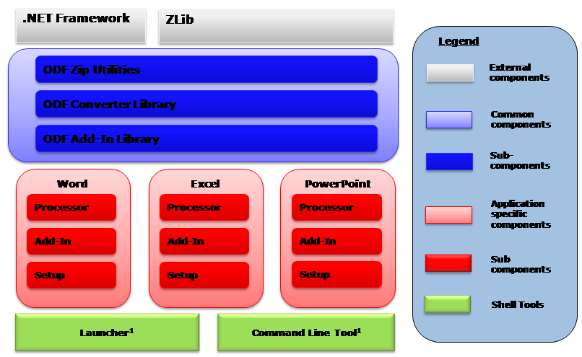
Figure 1: SW Component Architecture

Components Overview
The following is a brief description of each component.

External Components
The external components are third party components which were re-used for this project:
- zlib is a free software/open-source, cross-platform data compression library. It is an abstraction of the DEFLATE compression algorithm used in the gzip file compression program. The first public version was originally intended for use with libpng image library. zlib is distributed under the zlib license. We use this library to access ODF and OOX files’s content.
- The Microsoft .NET Framework provides a large body of pre-coded solutions to common program requirements, and manages the execution of programs written specifically for the framework. In our case we use it essentially for the XSL processor and to integrate the converter as an MS Office Add-In.

Common Components
The common components are a collection of components shared across the application specific implementations:
- ODF Zip Utils: provides a .NET API for reading and saving ZIP files. This is based on the zLib external component.
- ODF Converter Library: implements the whole transformation processing chain in both directions. It also implements the resolvers (see section 5.3.1.2), the common post-processors, and instantiates the XSL processor engine.
- ODF Add-In Library: This is the common code to the Add-In and implements the converter dialog boxes, manages message events & initiates the conversion.

Application Specific Components
These components are application specific and provide seam-less integration with the rest of the architecture.
- Processor: This is a container for the xsl transform documents as well as the post-processors.
- Add-In: This is the component responsible for displaying the ODF Menu in the application.
- Setup: Installation utilities.

Shell Tools
These are peripheral tools which are not directly integrated in the final applications. Note that those utilities only use the processor sub-components from the application layer.
- Launcher: A utility allowing the user to convert (and open) an ODF document directly from windows explorer.
- Command Line Tool: A utility performing conversions from the command line.

Sub-Components implementation
The following is a detailed description of each of the components constituting the framework.

Common Sub-components

ODF Zip Utils
In addition to providing an API for handling ZIP files, the ODF Zip Utils library provides a way to package XML fragments and external binary files into a ZIP archive. It is done through the ZipArchiveWriter class, which is a custom implementation of System.Xml.XmlWriter.
The ODF Zip Utils library contains the following classes, which relations are depicted in Figure 2:
- ZipLib: Interop layer for zlib library
- ZipReader: Abstract class for ZIP file read operations
- ZipWriter: Abstract class for ZIP file write operations
- ZlibZipReader: Actual implementation of ZIP file read operations: derived from ZipReader and based on ZipLib
- ZlibZipWriter: Actual implementation of ZIP file write operations: derived from ZipWriter and based on ZipLib
- ZipArchiveWriter: package XML fragments and external binary files into a ZIP archive
- ZipEntryNotFoundException: Thrown when an entry is missing in the ZIP file
- ZipException: Thrown when other errors are encounted by the Zlib library.
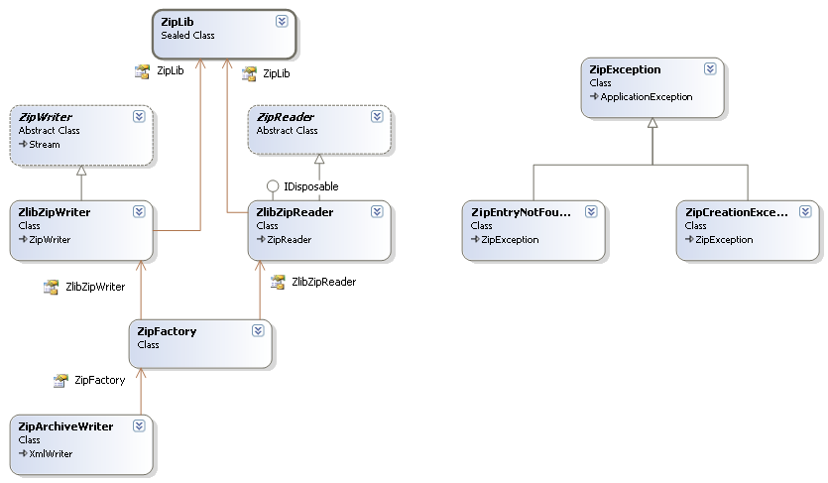
Figure 2: ODFZipUtils class relationship

ODF Converter Library
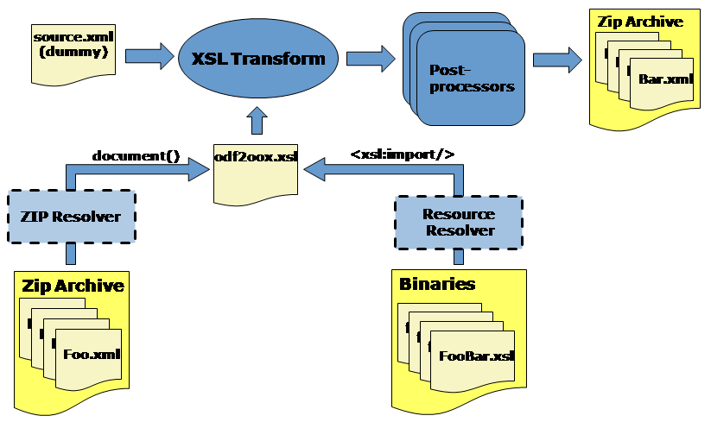
Figure 3: Logical Processing Chain
The main part of the converter library consists of XSL Transformations. Those are used to convert an XML serialization of ODF into an XML serialization of OOX and vice-versa.
Since the XSL transform sheets are embedded in a binary assembly during execution, a “resource Resolver” was created. This one allows to fetch XSL files at load time and is invoked by the xsl:import element during the transformation [1].
As both ODF and OOX are ZIP archives containing XML files and resources, a “ZIP resolver” that extracts the data from the archive has been implemented. Also, since the final result needs to be saved in a ZIP archive (whether it be OOX or ODF), a special post processor called the ZipArchiveWriter serializes a single XML file containing several logical blocks, each of which corresponding to a single XML file after post-processing. In order to be processed by the ZipArchiveWriter, the input XML stream must conform to the following structure:
<zip:archive zip:target="somePath">
<zip:entry zip:target="relativePath">
<!-- xml fragment to be packaged -->
</zip:entry>
<!-- other entries -->
...
</zip:archive>
In this scenario, the XSL transformation replaces all links, footnotes, images, etc. with references as it will be in the final XML files.
Figure 3 shows the various resolvers and the logical chain of events during a conversion. 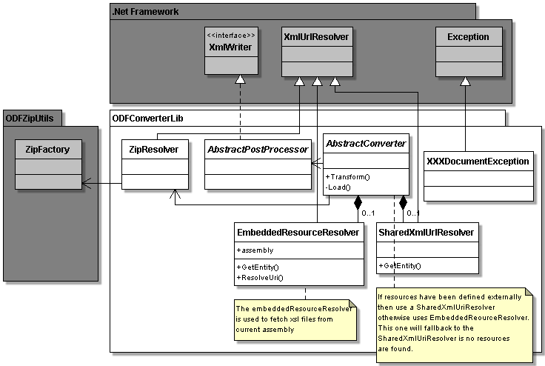
Figure 4: ODFConverterLib class relations
The ODF Converter Library contains the following classes [2] (see Figure 4):
- AbstractConverter: A common class providing the core XSL transforms implementation (i.e. instantiating and setting up the XSL processor, etc…), which relies on an Assembly attribute to locate application-specific embedded XSL resources. This class is implemented in the application specific component (see section 5.3.2.1).
- AbstractPostProcessor: This class provides straightforward implementations of all the abstract methods from XmlWriter and defines handy structures for representing XML elements and attributes.
- ZipResolver: Locates and accesses zip resources (typically document parts) thanks to a zipReader implementation, which is obtained through the zipFactory (see section 5.3.1.1).
- XXXDocumentException: Exceptions raised during the conversion process
- EmbeddedResourceResolver: Used to locate and access embedded resources (i.e. xsl stylesheets).
- SharedXMLURLResolver: TBD

ODF Addin Library Component
This component provides a user interface to the ODF Converter:
- It handles a file selection dialog box allowing the user to select one or more files to be converted and opened.
- It displays a progress bar dialog with the option for the user to cancel the conversion.
The OdfAddinLib is also responsible for managing localized UI resources. It exposes default localized resources and it is possible to override them by redefining them in the ODFXXXAddIn component (see 5.3.2.2.1).
This component is build of three classes (see Figure 5):
- OdfAddInLib: A utility class containing all the common routines used by the add-in. It is the main class of this component and initiates the conversion.
- ConvertForm: Provides the progress bar with the cancel button as well as the conversion’s result.
- InfoBox: Dialog box providing event feedbacks (e.g. error messages, etc…).

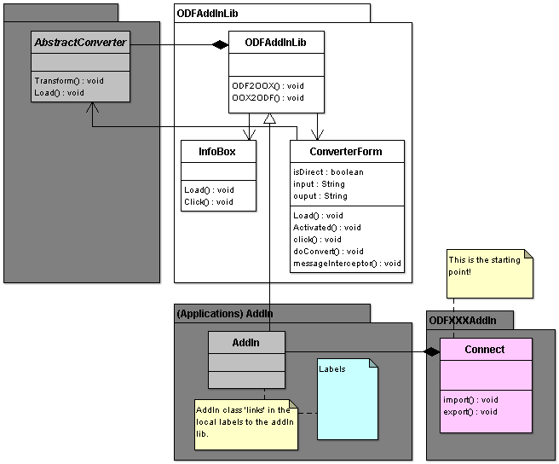
Figure 5: ODFAddInLib class relations

Application Specific Components

Converter Component
This component is an implementation of the ODF Converter Library component and is responsible for defining application specific post-processors as well as xsl transforms (see XSL resources in Figure 6 below).
This component contains the following class (see Figure 6):
- Converter: This class extends the absrtactConverter class to define the
- xxxPostProcessor: Post-processors. These are called after the XSL transform and are used to address the limitation of XSLT or to optimize processing time.

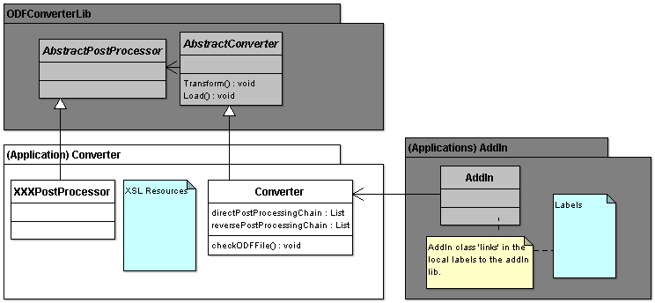
Figure 6: Application Specific Converter classes and their relations

Add-In Components
There are two categories of Add-In components.

Application Add-Ins
These components are responsible for loading the add-in and displaying the ODF Menu in the application. Since, each hosting application is different, it is necessary to have specific implementation for each version of the application.
These components are made of the following class/files (see Figure 7):
- Connect: This class is the add-in entry point. It implements the IDTExtensibility2, which provides the necessary events required for a program to be an Add-in. For Office 2007, it also implements the IRibbonExtensibility interface, which is used to customize the UI (i.e. add a menu item). Upon user events it will load the add-in and quick off the conversion.
- AssemblyInfo: This is a special resource file, which provides valuable information about the add-in (e.g. add-in name, version, publisher, etc…). This information is displayed in the applications’ add-in manager.
- ConverterInterface: This is a COM interface definition, which allows performing conversions from external process. It is implemented by the connect class and is particularly handy for automation work.

Add-In
This component is an implementation of the ODF Add-In Library component and is responsible for defining resource labels (see .resx resources) specific for the application. Since labels are common to all versions to a given application, the component is shared by the application add-ins through an association relation as shown in Figure 7. This component only contains the AddIn class.
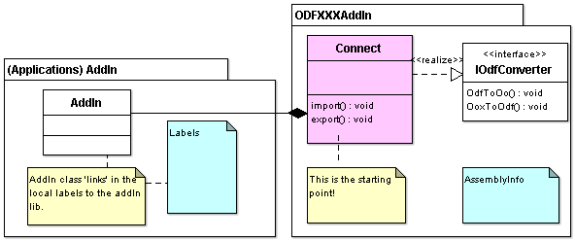
Figure 7: Add-In and Application add-ins relationship

Setup Component
This is a special component, which is responsible for building the installation program and is common to all versions of the application. In addition to providing an install wizard to the user, it verifies that the target environment complies with the software pre-requisites, and (if necessary) downloads and copies the required components. On completion it displays a readme file to inform the user about the latest information.
This component does not contain any class as all the tuning is done within visual studio forms.

Shell Components

ODF Converter Test
This component is the command line translator. It currently offers the possibility to either convert an ODF file or to validate the XML schema of a resulting file.
This component is build of two classes:
- OdfConverterTest: Entry point of the translator; parses the parameters and launch the conversion process
- OoxValidator: Validates the schema of a result file

Launcher Component
TBD

References
[1] | Technical Overview
Author | Olivier DURAND
Location | SVN://docs/Developer documentation/ODF Converter - A technical Overview.pptx

[2] | UML Modelisation
Author | Olivier DURAND
Location | SVN://docs/Developer documentation/ODFConverter.zargo

[RefId] | <Title>
Author
Location

…

Appendix A: UML Class diagram
